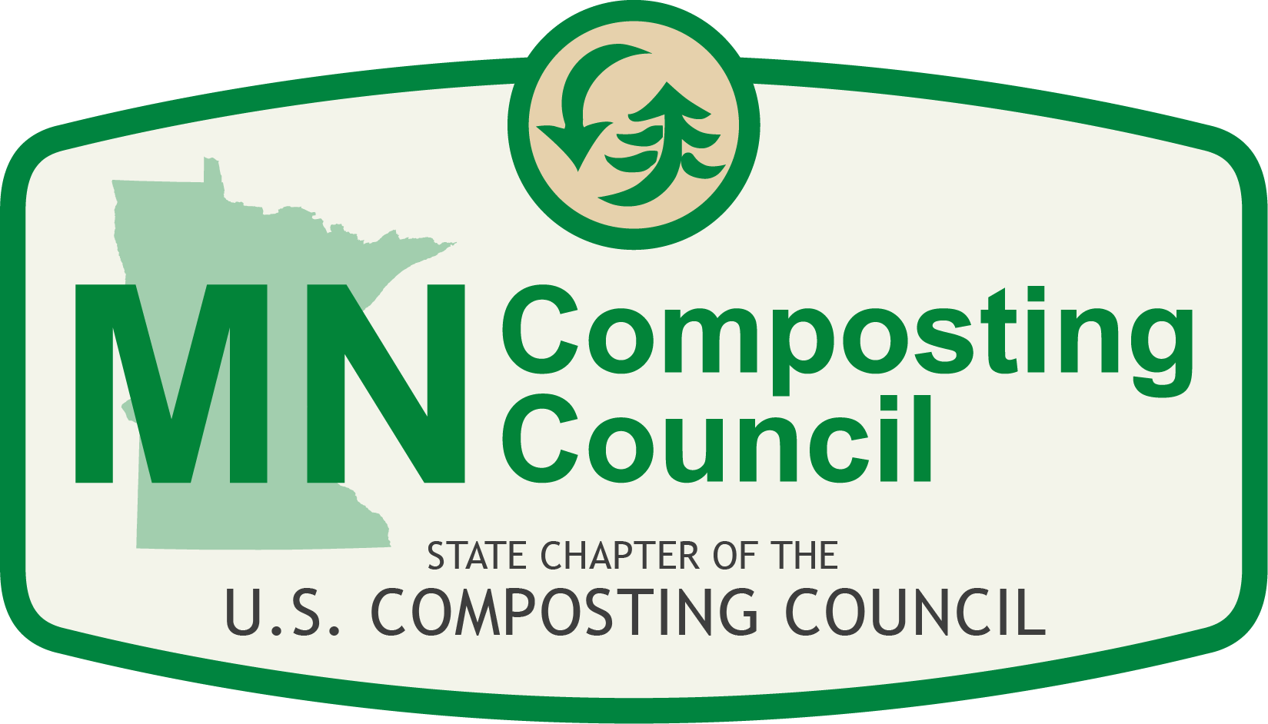

Minnesota Composting Council
2018 Board Nomination Form

There are four positions are up for election on the MNCC board in 2017. Board members hold three year terms, January 1, 2019 to December 31, 2021. If you are interested in running for the Minnesota Composting Council Board of Directors, please complete the nomination form below. To be eligible to run for the board, members must be a member of the MNCC for at least 1-year prior to the election of the Board and must remain a member in good standing with the USCC and the MNCC throughout the term in office.
Nomination forms must be emailed to compostmn@gmail.com by 4:00 p.m. on Friday October 18th, 2018. Late submissions will not be accepted. Elections will be held October 24th – 31st and newly elected board members will be announced in November.
Nominee’s Name
Organization
Phone
Email

Please also submit a photo to include with the nomination form.
Has Skills and Competencies in the Following Areas:

 | Administration / Business |  | Management
 | Financial Oversight |  | Marketing / Public Relations
 | Fundraising |  | Media
 | Government Operations |  | Policymaking / Lobbying
 | Legal |  | Public Education / Outreach

Please provide additional detail on the following. The application should be no more than two typed pages.
- Certifications, degrees, and/or licenses currently held
- Other nonprofit (or Board) experience
- Other affiliations
- Why would this person be an asset to the Board?

